TITLE – MANUSCRIPT PREPARATION INSTRUCTIONS

Thor Sion^{*1}, Victor B. Ration¹ and Sylvia M. Posium²

¹Institute for Galactic Torsion Vibration Research,
No. 42 Adams Road, Athurtown 0815, Ursa Minor Beta

²The Vibration Association
Hallwanger Landesstrasse 3, 5300 Hallwang/Salzburg, Austria

info@torsional-vibration-symposium.com (e-mail address of lead author)

Abstract
This is the abstract with up to 200 words.

INTRODUCTION
This document contains all information you need to prepare your manuscript for the Torsional Vibration Symposium, 2020.

Your complete paper
- must not exceed 8 pages (min. 4 pages)
- must be about current scientific topics related to the field of torsional vibration
- the Vibration Association must receive all papers as a Word- and PDF-file not later than January 17th, 2020 (if you have any problems in preparing a PDF-file, please get in touch with the Vibration Association),
- must be submitted in electronic form via e-mail to
info@torsional-vibration-symposium.com, and
- should be a Word and PDF-file with a file size of not more than 10 megabytes.

The title of the paper should be placed in the same position as it is above. Arial 15-point bold is preferred.

In preparing your manuscript, the paper should start with the Abstract, followed by the main paper body where the first paragraph would normally include an INTRODUCTION. It is preferable to label it as above, using the style indicated. The text should be written as a contribution to the torsional vibration literature, and not as a list of topics to be covered during the oral presentation.

PREPARING YOUR MANUSCRIPT
These instructions are written in a form that satisfies all of the formatting requirements for your manuscript. Please use them as a template in preparing your manuscript. Authors must take special care to follow these instructions concerning margins. The basic instructions are simple:

- Format the manuscript for an A4 size page.

- The top margin is 38 mm (1-½ inches).

- The bottom margin is 38 mm (1-½ inches).

- Use left and right margins of 32 mm (1-½ inch).

- The text shall have both the left and right margins justified

- Do not indent the first paragraph. The following paragraphs should be indented 10 mm.

TYPE FONTS AND STYLE
The manuscript must be typed in single-spacing. Use double-spacing only to set off equations, illustrations, figures, and tables. The body of the text should be prepared using Arial. This paragraph has been prepared using Arial.
This paragraph has been typed using Arial 12-point type – the smallest that is allowed for preparation of your manuscript. Note that while the first paragraph directly under the section heading has not been indented, this and subsequent paragraphs have been indented. The indent should be about
10 mm (0.4 inch). Note that there is no spacing between paragraphs (unless a subheading is used; see below).

SECTION HEADINGS
Section headings should be centred on the page and in capital letters only. The type, fonts, and style above (Arial 13-point bold) are an example of a section heading. A double space above and a single space below section headings must be included. Do not underline section headings. A bold font should be used for section headings.

Subheadings
Subheadings should be positioned on the left margin, in a bold-faced font the same size as the main text (Arial 12-point) with single spacing above and below. The first letter of each word in the subheading is to be capitalized.

Sub-Subheadings
Sub-Subheadings, such as this one, are integrated into the paragraph, and should be typed using italic bold-faced font the same size as that used for the body of the text. Only the first letter of each word in the subheading should be capitalized. Note that a blank line precedes and follows the subheading.

OTHER IMPORTANT INSTRUCTIONS REGARDING YOUR MANUSCRIPT
Your manuscript will have an attractive layout if you follow the style-related instructions given above. There are several other instructions that should be carefully followed:

Presenting Author: Max. two presenting authors. Please indicate the presenting author(s) with an asterisk.

Number of Pages: The manuscript must not exceed a maximum of 8 pages in length. The minimum is 4 pages.

Proofreading: Proofread your manuscript carefully. You are responsible for proofreading and correcting your manuscript before submitting it for publication. There will be no further proofreading or opportunity for changes.

Equations: Equation numbers should be right-aligned on the page and numbered consecutively beginning with (1). Equations should be separated from the body text by a single line of spacing, before and after them.

(1)

Units: The use of SI units is strongly recommended, and mixed units are to be avoided.

Tables: Tables should be framed. The font of a table heading is 11-point Arial Italic. Table captions should always be positioned above the tables.

Table 1 Measurement vessels and engines
 | Ship type | Engine type | BSR | Position of BSR  (% MCO speed)
Ship 1 | Panamax Bulker 1 | 6S60ME-C8.2 | 49-59 rpm | 55%-66%
Ship 2 | Panamax Bulker 2 | 6S60ME-C8.2 | 48-58 rpm | 54%-65%
Ship 3 | Cape size Bulker 1 | 6G70ME-C9.2 | 34-41 rpm | 44%-53%
Ship 4 | Cape size Bulker 2 | 6G70ME-C9.2 | 36-44 rpm | 48%-59%
Ship 5 | Ore Carrier | 6G70ME-C9.5 | 35-43 rpm | 45%-56%

Figures: All illustrations (line drawings, charts, plots, etc.) must be suitably reduced in size to fit the page. Nevertheless, all figures and tables must be of good quality and legible (e.g. jpeg-file with 300 dpi). For a diagram, please adjust the labelling of the axes if they are not legible. All figures must be individually numbered and captioned. Illustrations must be sharp and clear.

Figure and Photograph Captions: Have to be inserted using an 11-point Arial in Italics font.
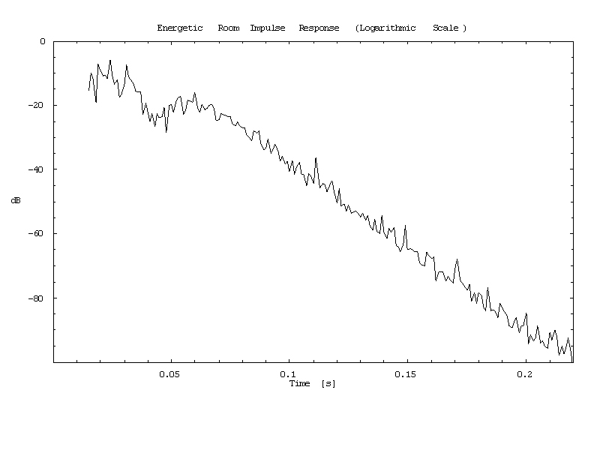
Figure 1 – Example of a figure with caption

Photographs: It is necessary that you reduce your photos and paste them in the text where you want them to appear (e.g. snipping-tool). Adjust the size of your pictures to meet the file size limit of max. 10 MB (e.g. 72 dpi).

Location of Illustrations and Size of Lettering: The illustrations suitably reduced in size should be preferably located within the text material, but may be located at the end of all text material. The illustrations and captions should be legible without having to turn the manuscript by 90 degrees.

SUMMARY (or CONCLUSIONS)
Following the body of the paper, the last section is normally the SUMMARY or CONCLUSION, and should be labeled as such.

REFERENCES
To save space, references may be set in 11- or 10-point type. This is the smallest type that should be used for references. All references should appear at the end of the paper. An example of the proper format for references is given below. If an italic font is not available, the words italicized in those examples should be underlined. For citations in the text please use square brackets and numbers: [1], [2]. The references should be listed in alphabetical order.

[1| Hafner K.E:, Maas H., Die Verbrennungskraftmaschine, Band 4: Torsions-schwingungen in der Verbrennungskraftmaschine, Springer (1985).
[2] B.I.C.E.R.A. (The British Internal Combustion Engine Research Association), Handbook on torsional vibration, Cambridge university press (1958)

OTHER IMPORTANT INFORMATION
Final Acceptance: The Symposium Advisory Board has the right to reject papers considered inappropriate to the Proceedings, even if the abstract originally appeared to be acceptable.

Please note that the official language of the Torsional Vibration Symposium 2020 is English.

Presentation of the Papers:

Unless you receive further notice, each presentation will be 25 minutes in total (20 minutes for the presentation, and 3 minutes for questions, 2 min. for the room change). Make sure that you are able to stay within these time limits. It should be presented only by one, max. 2 authors, more presenters are not permitted. The Presentation must be based on the paper submitted. Any information about the company must be limited to max. one slide. The deadline for Presentations is April 29th, 2020.

Please note that you are only allowed to make a presentation if your paper has been accepted by the reviewers.

Copyright:

By submitting a contribution to the Vibration Association, the author confirms that he or she holds the explicit right to use all contents (e.g. texts, pictures) of his / her abstract, paper and presentation. In the case of copyright infringement, the author shall be liable. The author also confirms that the material in the paper and presentation has not been previously copyrighted.
By submitting the full paper to the Vibration Association, the author agrees to give the copyright of the paper and the abstract to the Vibration Association.

